**Birla Institute of Technology & Science, Pilani**

**Online B.Sc. Computer Science Programme**

**First Semester 2023-2024**

**Comprehensive Exam**

**(Slot-2)**

Course No. : BCS ZC112

Course Title : Introduction to Logic

Nature of Exam : Open Book

Weightage : 50%

Duration : 3 hours

Date of Exam : 15 Oct 2023

Instructions to students:

1. Write your **name** and **ID** on every page of your submission. Pages not containing this will **not be evaluated**.
2. Parts of the same question should be answered **consecutively**. Attempt every new question **on a fresh page**. Mention the correct **question and subquestion numbers** for each answer.
3. Please ensure your submission is **clear and legible**. Marks will **not** be awarded for unclear and illegible answers.
4. **Assumptions** made, if any, should be stated clearly at the beginning of your answer.
5. Wherever a question mentions **restrictions** (“one word only”, “one sentence only”, or a blank to be filled), please **adhere** to them strictly.
6. **Not following any of the mentioned instructions can incur a penalty.**
7. [10 Marks]

Consider the following natural deduction proof for the validity of the sequent:

$$p ∨ ((p ∧ q) ∧ r) ⊢ p$$

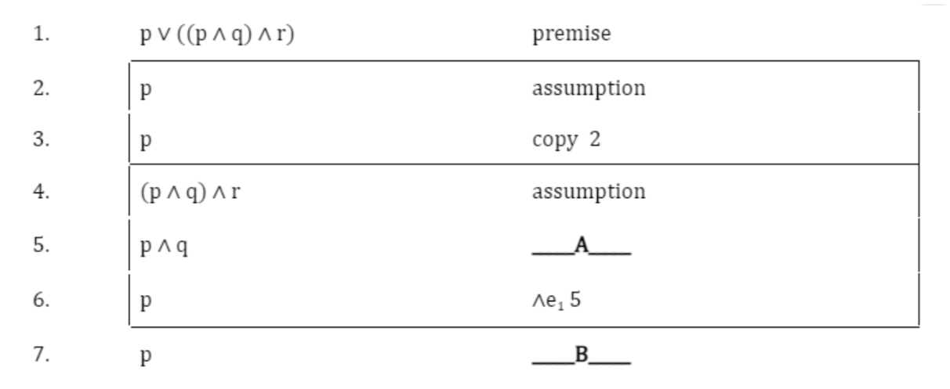

Fill in the blanks **A** and **B** to complete the above proof. *[4 + 6 = 10 marks]*

1. [8 Marks]

Consider the following natural deduction proof for the validity of the sequent:

$$¬p ⊢ p → q$$

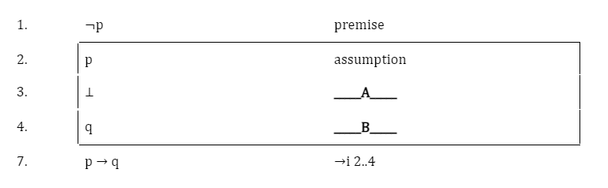

Fill in the blanks **A** and **B** to complete the above proof. *[4 + 4 = 8 marks]*

1. [12 Marks]

i) How many rows would our truth table have if we wish to use the truth table to check for the validity of the following propositional logic formula: **(p ∨ z ∨ ¬r) ∧ (¬p ∨ ¬q ∨ s) ∧ (r ∨ z ∨ ¬t)**? *[2 marks]*

ii) There are **____X____** pure literal/literals and **____Y____** unit clause/clauses in the propositional logic formula: **(p ∨ z ∨ ¬r) ∧ (¬p ∨ ¬q ∨ s) ∧ (r ∨ z ∨ ¬t)**. Fill in the blanks for X and Y. *[1.5 + 1.5 = 3 marks]*

iii) Answer the following questions as instructed:

1. “The propositional logic formula: **(p ∨ z ∨ ¬r) ∧ (¬p ∨ ¬q ∨ s) ∧ (r ∨ z ∨ ¬t)** issatisfiable.” Is the given statement True or False? If True, provide an assignment to *exactly two literals* from the given formula such that no matter what values the other literals take, the formula evaluates to True. If False, provide a DPLL trace for the given formula and show where the algorithm breaks down. *[0.5 + 2 = 2.5 marks]*
2. “The negation of an invalid formula is necessarily satisfiable.” Is this statement True or False? Explain your reasoning in *no more than* two sentences. *[0.5 + 2 = 2.5 marks]*

iv) With respect to natural deduction for propositional logic, we know that if φ1, φ2, . . . , φn |= ψ holds, then φ1, φ2, . . . , φn |– ψ is valid. What is this property known as? Answer in one word only. *[2 marks]*

1. [20 Marks]

Observe the following transition system, TS1, with the set of atomic propositions {p, q, r}. If a state does not have a particular literal mentioned, you can infer that the negation of that literal holds there.

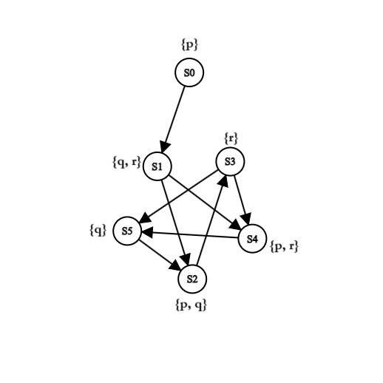

a) For each of the following LTL formulae $Φ_{i}$, does $TS1, S0 ⊨ Φ_{i}$?

In case $TS1, S0 ⊨ Φ_{i}$, write YES followed by enumerating all the possibilities.

In case $TS1, S0 ⊭ Φ_{i}$, write NO followed by an example of a contradiction to the formula. For example, you might give a state or path that violates the formula.

### i. $F ¬ (p → X (q ∨ r))$*[3 + 2 = 5 marks]* ii. $F (¬ p ∧ ¬ q)$*[3 + 2 = 5 marks]*

## 

b) For each of the following CTL formulae $Φ_{i}$, does $TS1, S0 ⊨ Φ_{i}$?

In case $TS1, S0 ⊨ Φ_{i}$, write YES followed by enumerating all the possibilities.

In case $TS1, S0 ⊭ Φ_{i}$, write NO followed by an example of a contradiction to the formula. For example, you might give a state or path that violates the formula.

### i. $A F (p ∧ r)$*[3 + 2 = 5 marks]* ii. $A F E G (q ∨ r)→ X p$*[3 + 2 = 5 marks]*

1. [6 Marks]

Use the predicate specifications:

b(X, Y): X beats Y

c(X): X is a cricket team

d(X, Y): X is defeated by Y

and the constant symbols:

z: New Zealand

g: England

s: Australia

to translate the following natural language statement into predicate logic:

***If New Zealand beat England, then New Zealand will not be defeated by any cricket team.***

1. [14 Marks]

Consider the following natural deduction proof for the validity of the sequent:

$∃y \left(\left(∀xP\left(x\right)\right)∨Q\left(y\right)\right) ⊢∃y ∀x\left(P\left(x\right)∨Q\left(y\right)\right)$ 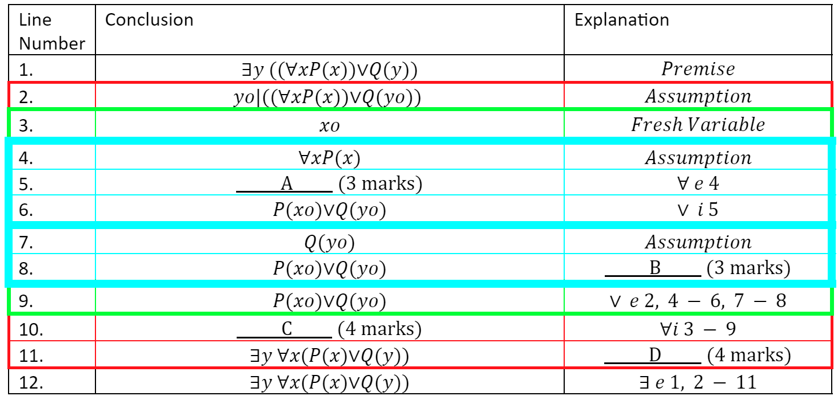

Fill in the blanks **A**, **B**, **C**, and **D** to complete the above proof. *[3 + 3 + 4 + 4 = 14 marks]*

1. [10 Marks]

You are given four predicate logic formulae below. Consider the model:

**U = {0, 1}**

**pM = {0}, qM = {1}**

For this model, find out whether each of the given formulae is satisfied by the model. Then, justify each of your answers with proper reasoning as demonstrated in the classes and quizzes.

a. **(∀X (p(X) ∧ q(X)) → (∃X (p(X) ∨ q(X))** *[0.5 + 2 = 2.5 marks]*

b. **(∀X (p(X) ∧ q(X)) → (∃X (p(X) → q(X))** *[0.5 + 2 = 2.5 marks]*

c. **(∃X (p(X) ∨ q(X)) → (∃X (p(X) → q(X))** *[0.5 + 2 = 2.5 marks]*

d. **(∀X (p(X) ∨ q(X)) → (∃X (p(X) ∧ q(X))** *[0.5 + 2 = 2.5 marks]*

1. [20 Marks]

Study the following program carefully and answer the questions given below:

void swap(int* x, int* y){

// PRE: ?

*x = *x + *y;

*y = *x - *y;

*x = *x - *y;

// POST: *x == B ^ *y == A

}

int main(void){

int a[10] = {10,9,8,7,6,5,4,3,2,1};

int n = 10;

int i = n - 2;

while (i >= 0){

int j = i;

while (j < n - 1 && a[j] > a[j+1]){

swap (&a[j], &a[j+1]);

j = j + 1;

}

i = i - 1;

}

}

i) Consider the *swap()* function. Given the postcondition:

// POST: *x == B ^ *y == A

Derive the pre-condition **PRE** using Floyd-Hoare Logic. *[5 marks]*

(ii) Give the loop invariants for each of the loops in the main program (outer and inner). Express them in predicate logic only. *[4 + 6 = 10 marks]*

(iii) Identify a quantity that reduces at every iteration of the outer loop. And then prove that this quantity actually reduces for each iteration and eventually reaches the terminating condition. Please write the proof formally. *[5 marks]*

***********